Ideation Phase
Define the Problem Statements

Date | 28 June 2025
Team ID | NM2025TMID00377
Project Name | Calculating Family Expenses using Service Now
Maximum Marks | 2 Marks

Customer Problem Statement Template:
Families face challenges when trying to manually track their monthly expenses across multiple categories and family members. This leads to inaccurate budgeting and difficulty in identifying spending patterns. It creates confusion among family members who need visibility into shared expenses and individual contributions. Lack of automated expense reports can also impact financial planning and savings goals. They need a way to centralize expense tracking in ServiceNow with automated categorization and real-time reporting, ensuring accurate financial records and budget management. A clear notification system for overspending alerts and automated monthly summaries would help avoid budget overruns. This solution will improve financial awareness and help families make informed spending decisions.

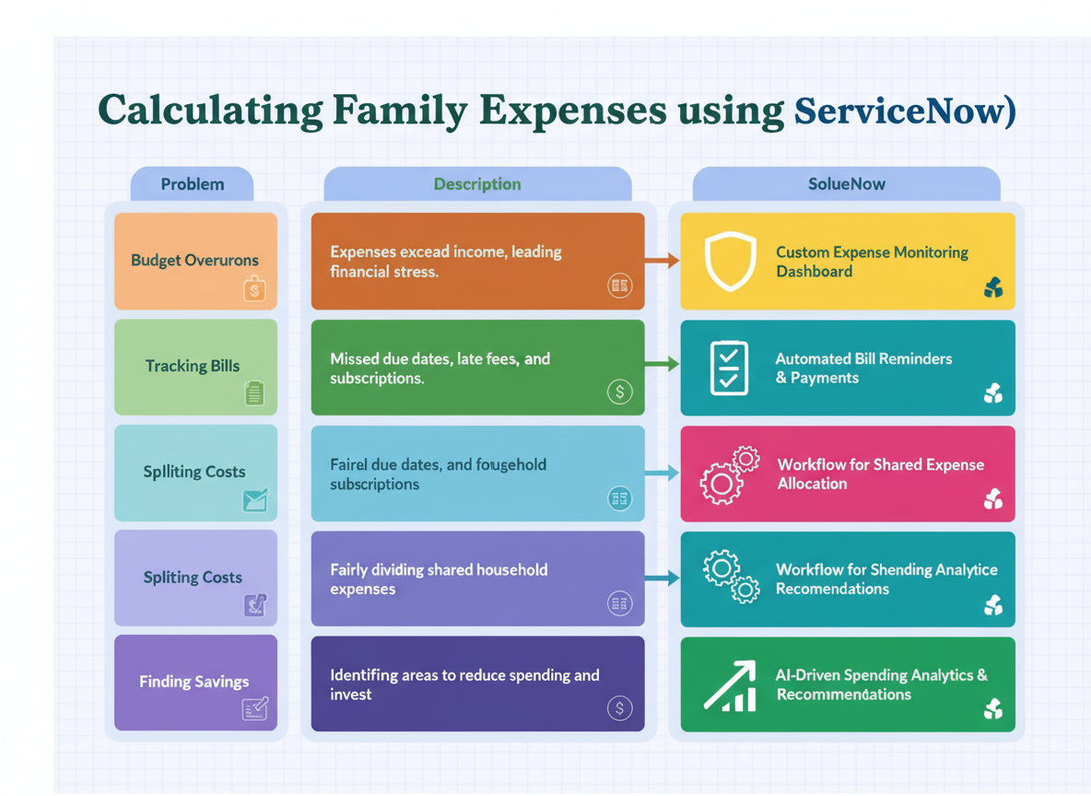

Example:

Problem  Statement (PS) | Iam  (Customer) | I’mtrying to | But | Because | Which makes me feel
PS-1 | a Family Member | View accurate monthly expense reports | the  the reports are often incomplete or inaccurate | the user is  expenses are tracked manually without automation  incidents | uncertain about spending patterns
PS-2 | A Team  Family Financial Manager | Manage  incident  Set up alerts for overspending | no automatic notifications are available | there's no  alert or  automatic  the system lacks proactive budget monitoring  active  incident  assignments | anxious about budget control

Problem Statement PS 1:
As a family member, I am trying to view accurate monthly expense reports to understand our household spending, but the system shows incomplete or inaccurate data because expenses are tracked manually without automation. This limitation makes me feel uncertain about spending patterns, as I cannot rely on the reports for financial planning. It creates confusion when trying to budget for upcoming months, especially during critical financial decisions. I need a better way to access real-time, accurate expense data that is automatically categorized and summarized in ServiceNow.

Problem Statement PS 2:
As a team manager, Iwant to ensure that incidents are properly reassigned when a user is removed. However, the system allows deletion without any warning or summary of
assigned tasks.
This causes incidents to be left unmanaged, which affects team performance and service quality. A built-in alert or automatic reassignment would reduce errors and maintain
accountability.

